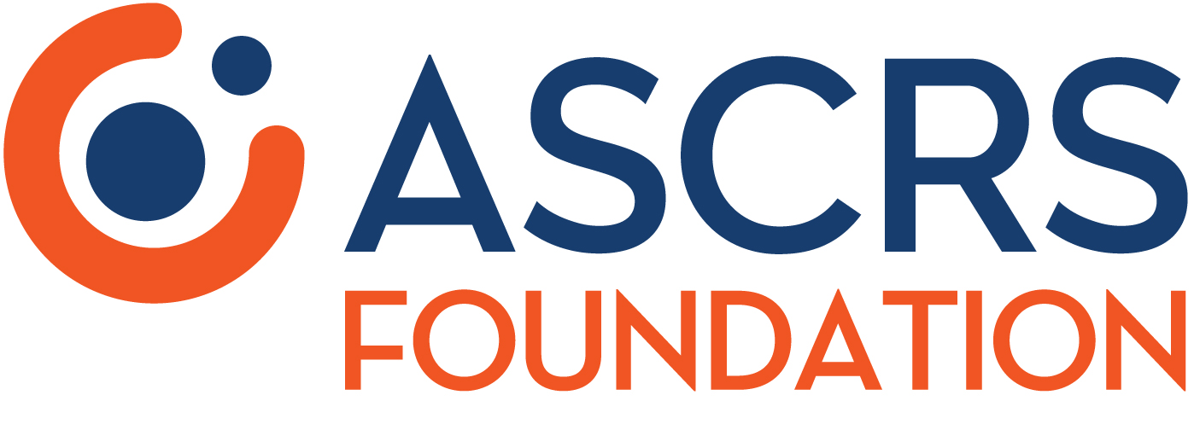
FOR IMMEDIATE RELEASE
MEDIA CONTACT: CONTACT NAME
PHONE NUMBER; EMAIL ADDRESS

OPHTHALMOLOGY OFFICE NAME to Participate in National Sight Week
Local Eye Surgeons Will Provide Free Cataract Surgery to Patients in Need

CITY, STATE – DATE – The OPHTHALMOLOGY OFFICE NAME is pleased to announce its participation in the 6th Annual National Sight Week (October 14-23), sponsored by the American Society of Cataract & Refractive Surgery (ASCRS) Foundation.

During National Sight Week, DR(S). NAME(S) will be performing free cataract surgery for local, eligible patients.

QUOTE FROM LOCAL PARTICIPATING OPHTHALMOLOGIST

National Sight Week is a celebration of volunteerism, during which members of the ASCRS Operation Sight network are encouraged to contribute one or more charitable cataract surgeries in their own communities. The ASCRS Foundation works to match eligible patients in need with local volunteer surgeons.

Operation Sight is the ASCRS Foundation’s domestic charitable cataract surgery program. Its mission is to assist uninsured or underinsured American patients, who cannot obtain cataract care on their own. By leveraging the combined strength of established charitable organizations along with ASCRS-member volunteer surgeons, Operation Sight provides needed care to those unable to access or afford surgery.

The OPHTHALMOLOGY OFFICE NAME will work closely with Operation Sight to identify eligible patients to receive free cataract surgery as a part of the practice’s participation in National Sight Week. Individuals interested in being considered should visit ascrs.org/foundation/operation-sight to apply. Potential candidates are encouraged to apply as soon as possible to complete the detailed vetting process prior to National Sight Week.

For more information about the charitable work being done by the OPHTHALMOLOGY OFFICE NAME during National Sight Week, contact CONTACT NAME at PHONE NUMBER AND/OR EMAIL ADDRESS. For more information about Operation Sight and National Sight Week, visit ascrsfoundation.org.

INSERT BACKGROUND INFORMATION ABOUT OPHTHALMOLOGY OFFICE

The American Society of Cataract and Refractive Surgery Foundation is a 501(c)(3) organization founded in 2003. Through its projects in the United States and overseas, the Foundation works to improve physician education and to deliver humanitarian eye care. ASCRSFoundation.org
# # #

